***Java Mini Project***

***Topic:- Energy Billing System***

***Code :-***

import java.awt.*;

import javax.swing.*;

import java.io.*;

import java.awt.event.*;

public class EBS extends JFrame implements ActionListener

{

JLabel l1,l2,l3,l4,l5,l6,l7,l8,l9;

JButton b1,b2,b3;

JTextArea ta1,ta2,th,tf,tb,tt;

JTextField t1,t2,t3,t4,t5,t6,t7;

JPanel contentPane;

public EBS()

{

contentPane = (JPanel) this.getContentPane();

th=new JTextArea("\n"

+" INDRA E-Energy Limited"+"\n"

+

"Contac No-xxxxxxxxx"+"\n"

+"Adres- Ahmedabad, India"+"\n"+

"========================================================="+"\n");

tt=new JTextArea("\n"+"\n"+"\n"+"\n"+"\n"+"\n"+"\n"+"\n"+"\n"+"\n"+"\n"+"\n"+"\n"+"\n"+"\n"+"\n"+"\n"+"\n"+"\n"+"\n"+"\n"+"\n"+

"\n"+"\n"+"========================================================="+

"\n"+"Developed by Indra Kumar"+"\n"

);

tf=new JTextArea("\n"+"========================================================="+

"\n"+"Developed by Indra Kumar"+"\n"

);

l1=new JLabel("Energy Billing System");

l1.setBounds(130,20,500,60);

l1.setFont(new Font("Bold",20,50));

contentPane.add(l1);

l2=new JLabel("Coustmer Name : ");

l2.setBounds(10,120,120,20);

contentPane.add(l2);

t1=new JTextField(10);

t1.setBounds(130,117,150,30);

contentPane.add(t1);

l3=new JLabel("Address : ");

l3.setBounds(10,170,100,20);

contentPane.add(l3);

ta1=new JTextArea(10,20);

ta1.setBounds(130,167,150,80);

contentPane.add(ta1);

l4=new JLabel("Meater no : ");

l4.setBounds(10,270,100,20);

contentPane.add(l4);

t2=new JTextField(10);

t2.setBounds(130,267,150,30);

contentPane.add(t2);

l5=new JLabel("Date : ");

l5.setBounds(10,320,100,20);

contentPane.add(l5);

t3=new JTextField(10);

t3.setBounds(130,317,150,30);

contentPane.add(t3);

l6=new JLabel("Units Used : ");

l6.setBounds(10,370,100,20);

contentPane.add(l6);

t4=new JTextField(10);

t4.setBounds(130,367,150,30);

contentPane.add(t4);

l7=new JLabel("CGST : ");

l7.setBounds(10,420,100,20);

contentPane.add(l7);

t5=new JTextField("18%");

t5.setBounds(130,417,150,30);

t5.setEditable(false);

contentPane.add(t5);

l8=new JLabel("Total Amount : ");

l8.setBounds(10,470,100,20);

contentPane.add(l8);

t6=new JTextField(10);

t6.setBounds(130,467,150,30);

t6.setEditable(false);

contentPane.add(t6);

ta2=new JTextArea(th.getText()+tt.getText());

ta2.setBounds(350,120,400,500);

contentPane.add(ta2);

b1=new JButton("Calculate Bill");

b1.setBounds(20,640,150,30);

contentPane.add(b1);

b2=new JButton("Generate Bill");

b2.setBounds(190,640,150,30);

contentPane.add(b2);

b3=new JButton("print");

b3.setBounds(500,640,150,30);

contentPane.add(b3);

b1.addActionListener(this);

b2.addActionListener(this);

b3.addActionListener(this);

}

public void actionPerformed(ActionEvent ae)

{

if(b1==ae.getSource())

{

int n1=Integer.parseInt(t4.getText());

if(n1<100)

{

n1=n1*2;

}else if(n1<300)

{

n1=100*2+(n1-100)*2;

}else if(n1>300)

{

n1=100*2+200*2+(n1-300)*3;

}

t6.setText(Integer.toString(n1)+".00");

}

if(b2==ae.getSource())

{

ta2.setText(th.getText()+ "\t"+"\t"+"\t"+"Date : "+t3.getText()+"\n"+

"Coustmer Name : "+t1.getText()+"\n"+"\n"+

"Address : "+ta1.getText()+"\n"+"\n"+

"Meter no :"+t2.getText()+"\n"+"\n"+

"\t"+"\t"+"Electricity Bill"+"\n"+

" ---------------------------------------------------------------------------------"+"\n"+

" Item"+"\t"+" Meter no"+"\t"+" Units"+"\t"+" Total"+"\n"+

" ---------------------------------------------------------------------------------"+"\n"+

" Elec"+"\t"+" "+t2.getText()+"\t"+" "+t4.getText()+"\t"+" "+t6.getText()+"\n"+

" ---------------------------------------------------------------------------------"+"\n"+

"\t"+"\t"+"\t"+" "+t6.getText()+"\n"+

" --------------------"+"\n"+

"\t"+"\t"+"Adding CGST"+" "+t5.getText()+"\n"+

" --------------------"+"\n"+

"\t"+"\t"+"Final Bill to pay"+" "+t6.getText()+"\n"+

" --------------------"+"\n"+

"\n"+"\n"+

tf.getText());

}

if(b3==ae.getSource())

{

try

{

// print the file

ta2.print();

}

catch (Exception evt){}

}

}

public static void main(String args[])

{

EBS e=new EBS();

e.setSize(800,720);

e.setTitle("Energy Billing System - Mini Project - Indra");

e.setLayout(null);

e.setVisible(true);

e.setBackground(Color.red);

e.setDefaultCloseOperation(JFrame.EXIT_ON_CLOSE);

}

}

***Output:-***

***//Compile and run Program***

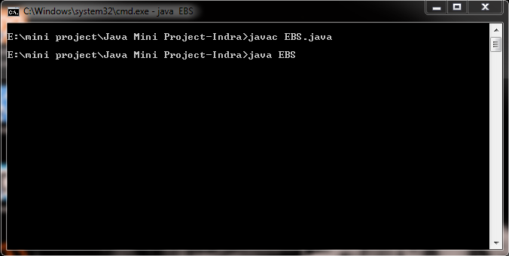

***//Input user details in the project***

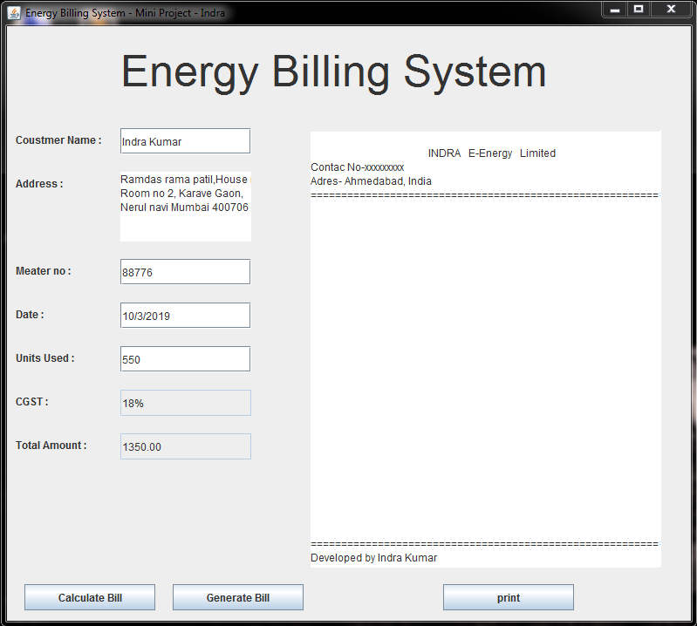

***//Generating the Bill***

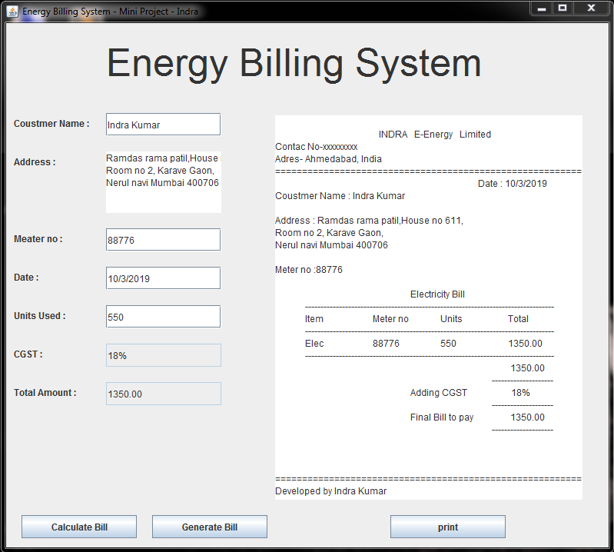

***//Printing the Bill***

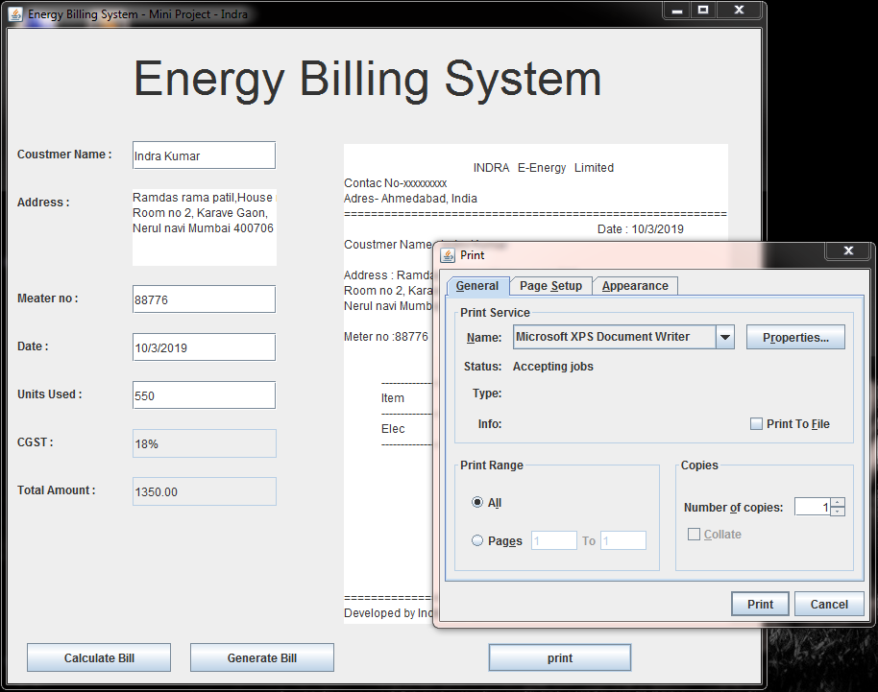

***//Printed Bill***

